**Interview Questions**

**Note: Write down this interview question on your notebook ,Take a screenshort & Paste that SS in the word document & upload on your Github.**

**What does the static keyword mean in Java? Explain the difference between static and non-static methods.**

1. What is the role of the static keyword in the context of memory management.

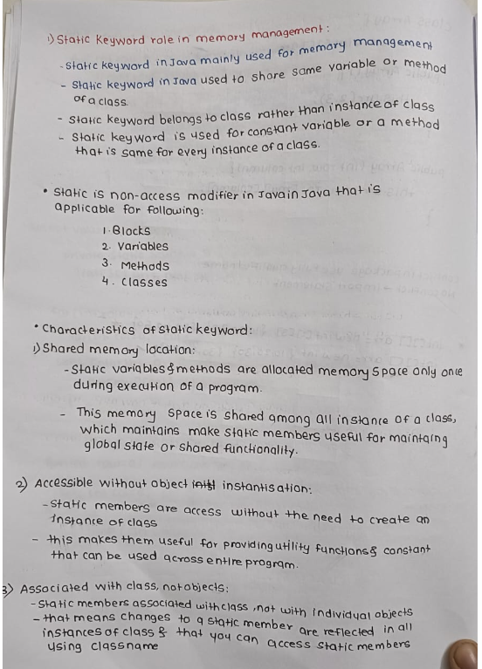

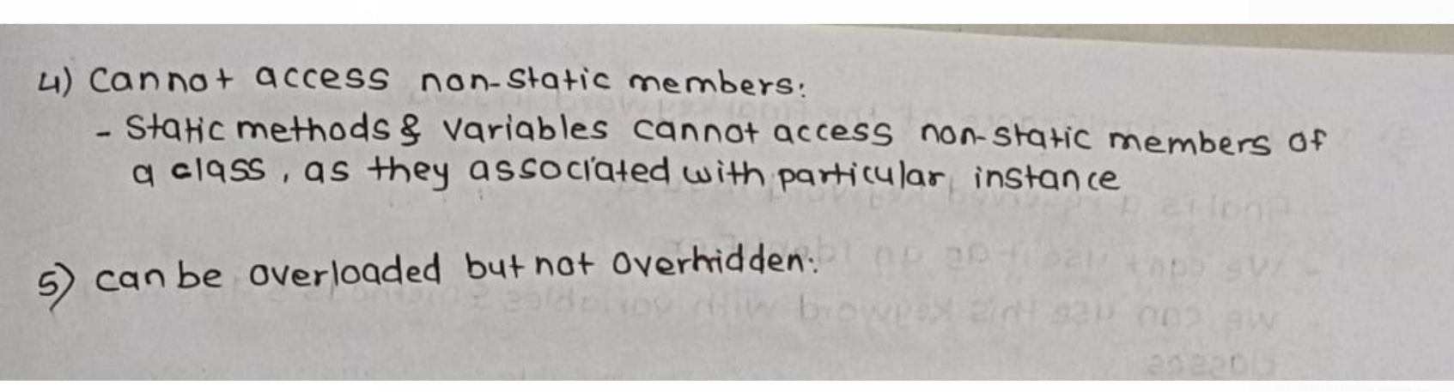

1. Can static methods be overloaded and overridden in Java?Howstatic variables shared across multiple instances of a class?

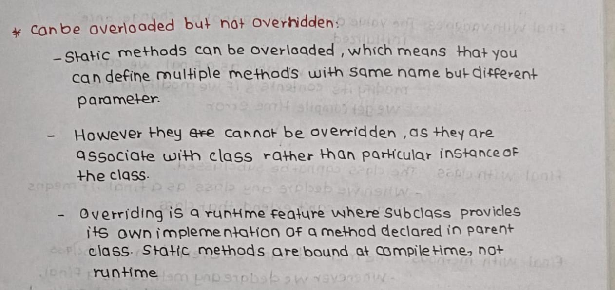

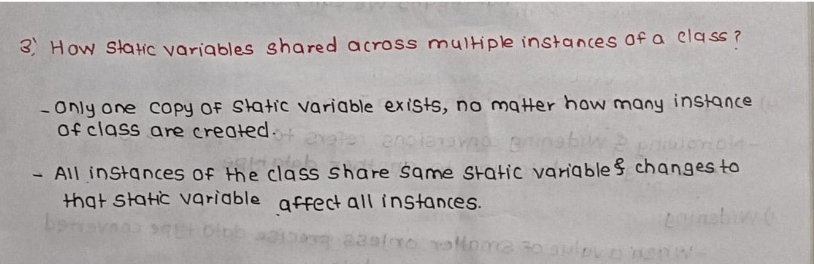

1. What is the significance of the final keyword in Java?

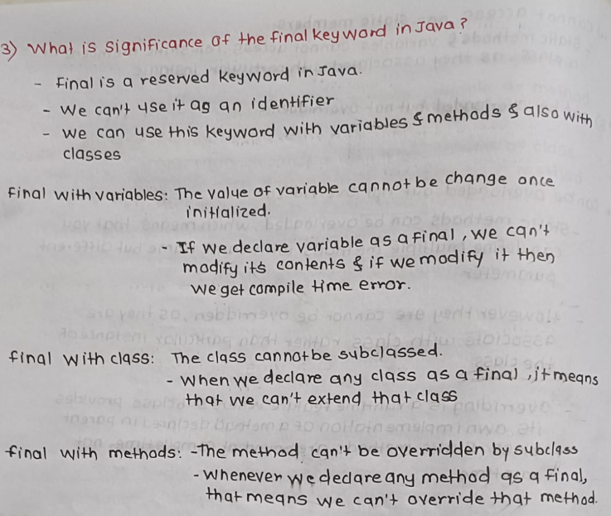

1. What are narrowing and widening conversions in Java?

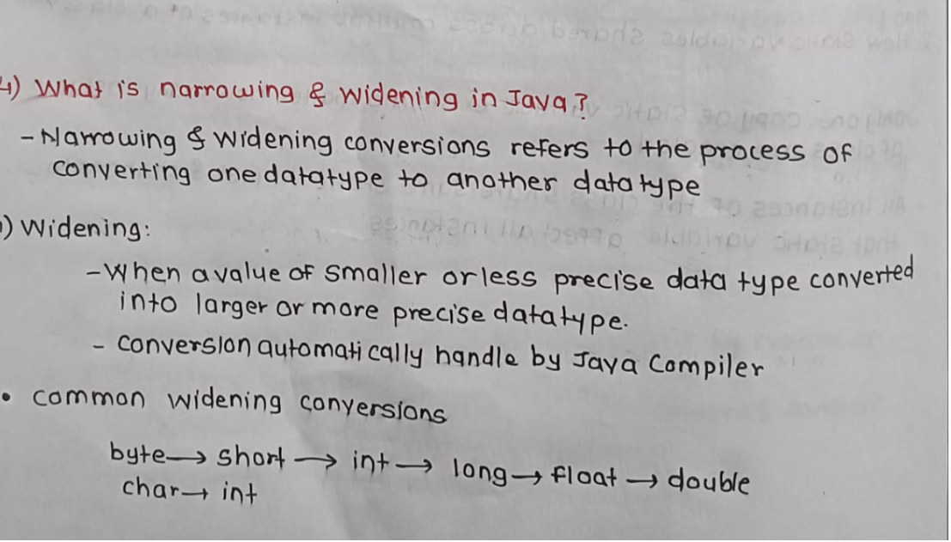

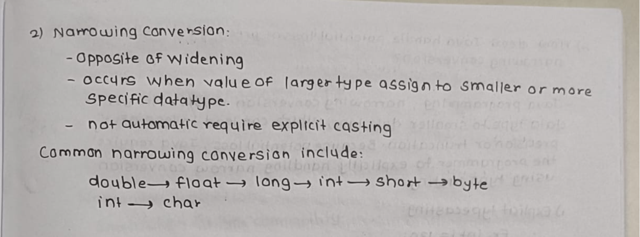

1. Provide examples of narrowing and widening conversions between primitive data types.

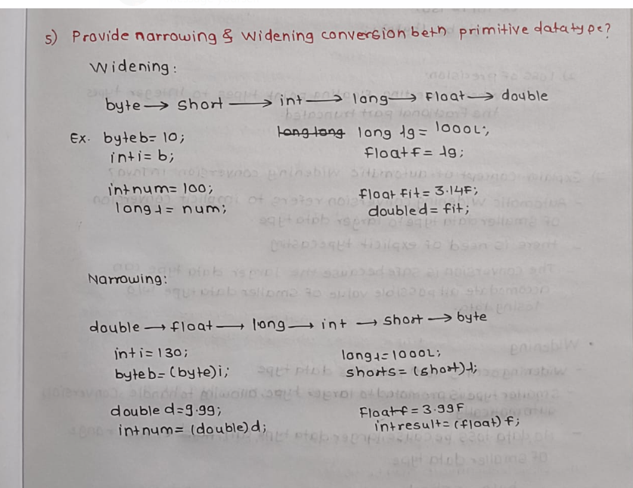

1. How does Java handle potential loss of precision during narrowing conversions?

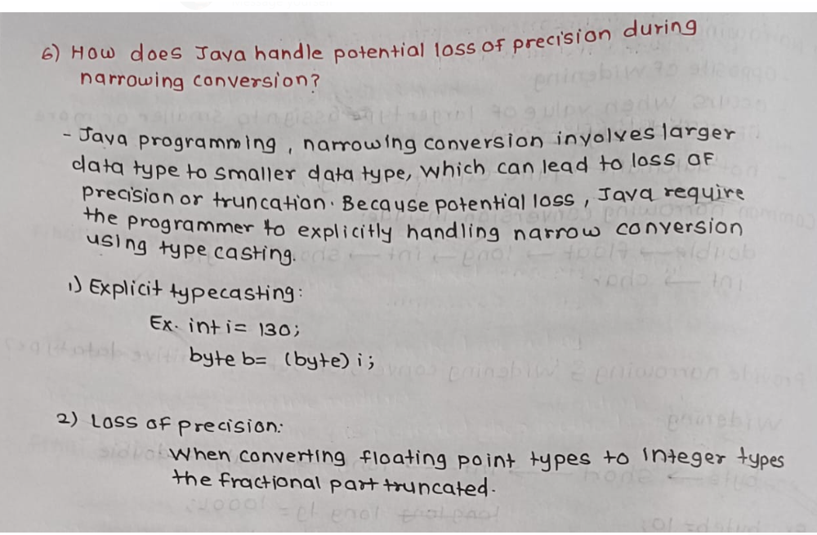

1. Explain the concept of automatic widening conversion in Java.

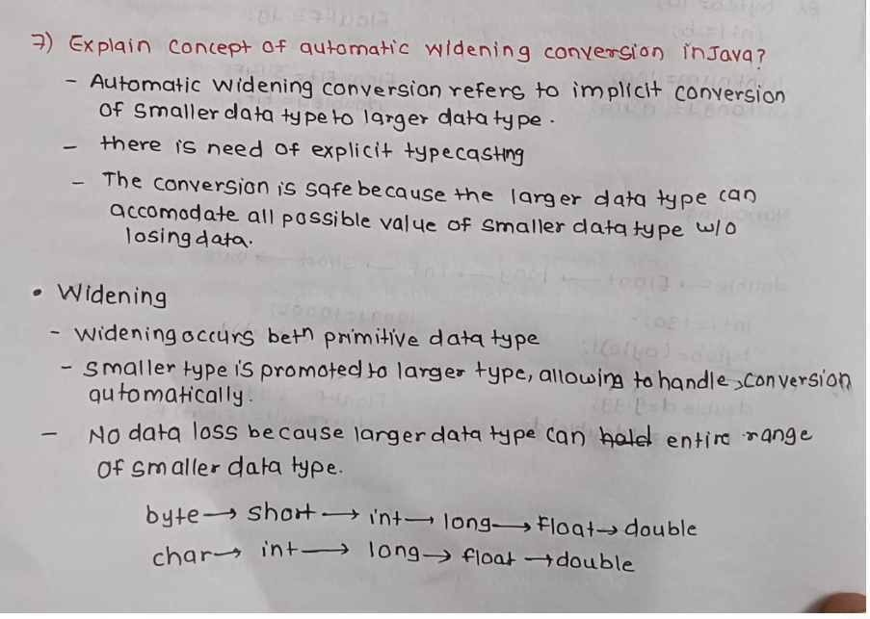

1. What are the implications of narrowing and widening conversions on type compatibility and data loss?

